Module creation

1. If we want expose a module then it should be decorated with NgModule.
2. NgModule is part of @angular/core library.
3. NgModule is a decorator.

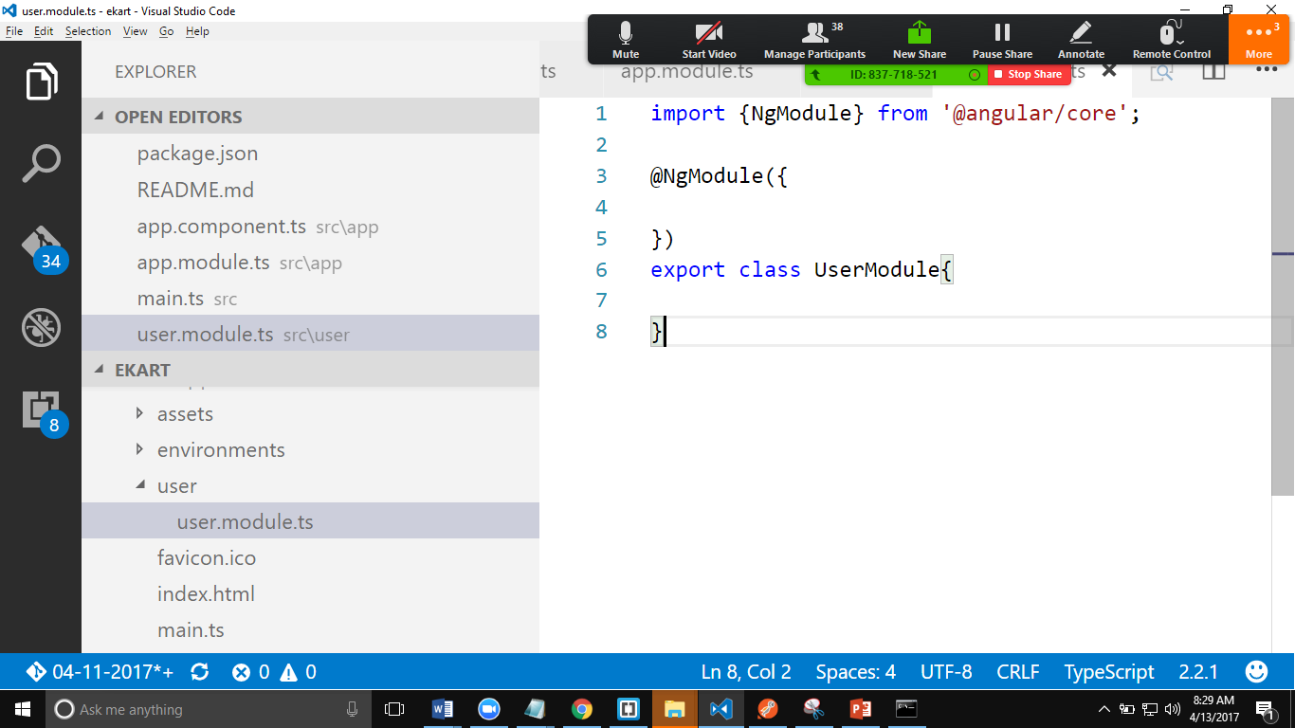

Main.ts 🡺app.module.ts🡺app.component.ts

Creating Component.

1. Import the “Component” from @angular/core.
2. Export class HeaderComponent

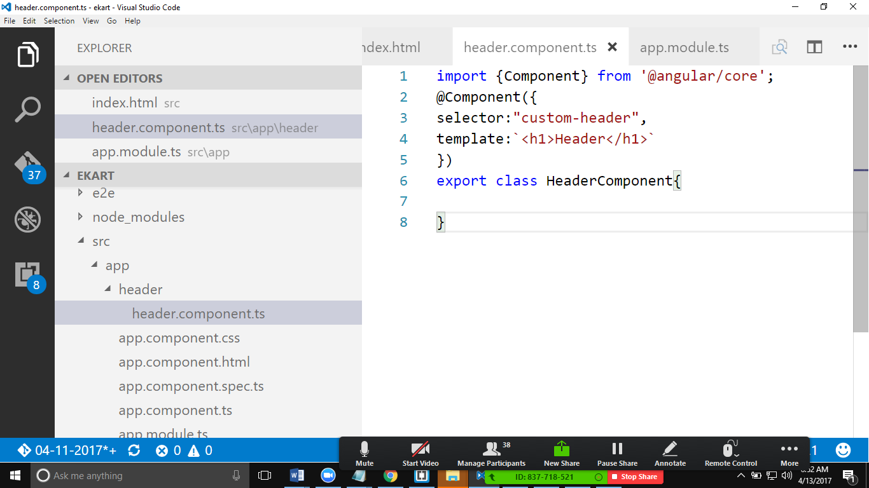

1. Refer the HeaderComponent in app.module.ts
2. Register it as part of declarations.

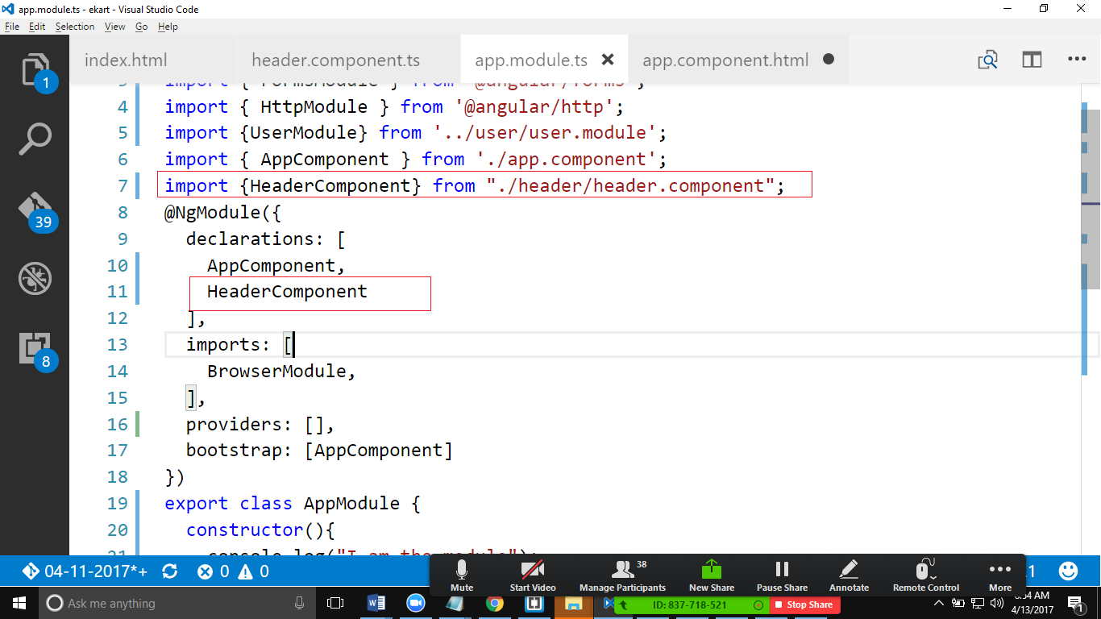

Use component in the app.component.html.

